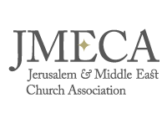

Suggested Legacy Clause wording:

Residuary bequest
Subject to the payment of my debts, funeral and testamentary expenses, I give the whole/…..% of my estate not otherwise disposed of by this my Will to The Jerusalem and the Middle East Church Association (UK registered charity number 248799) of 1 Hart House, The Hart, Farnham, Surrey GU9 7HJ for the general purposes of JMECA and I declare that the receipt of its Administrator or other proper officer shall be a full and sufficient discharge.

Pecuniary bequest
I give free of tax to The Jerusalem and the Middle East Church Association (UK registered charity number 248799) of 1 Hart House, The Hart, Farnham, Surrey GU9 7HJ, the sum of £….. for the general purposes of JMECA and I declare that the receipt of its Administrator or other proper officer shall be a full and sufficient discharge.

